CREATINGIBMCLOUDSERVICE

|  |  |
| --- | --- |
| Date | 19September2022 |
| TeamID | PNT2022TMID06413 |
| ProjectName | Project–Real-TimeRiverWaterQuality  MonitoringandControlSystem |

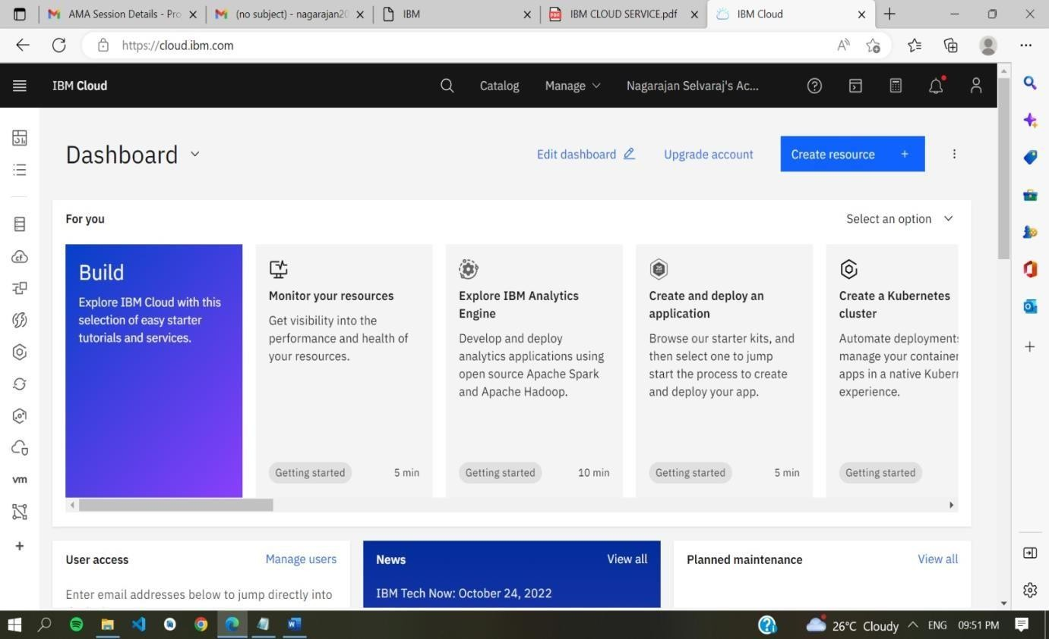

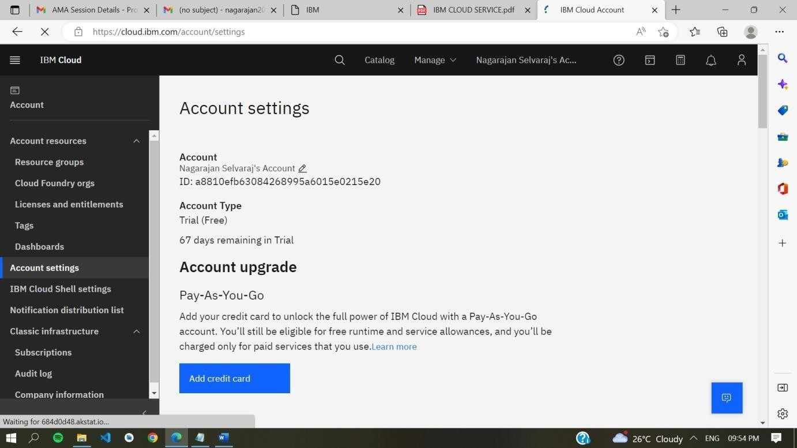

AnIBMCloudServicecreatedSuccessfully.